Stage 3 – Mr. Poopy Says Practice More
COURSE DESIGNER: Kyle Narkum / John Royer
SCORING: Comstock 30 rounds.
TARGETS: 14 cardboard targets, 2 steel targets
SCORED HITS: 2 Best hits per carboard will be scored.

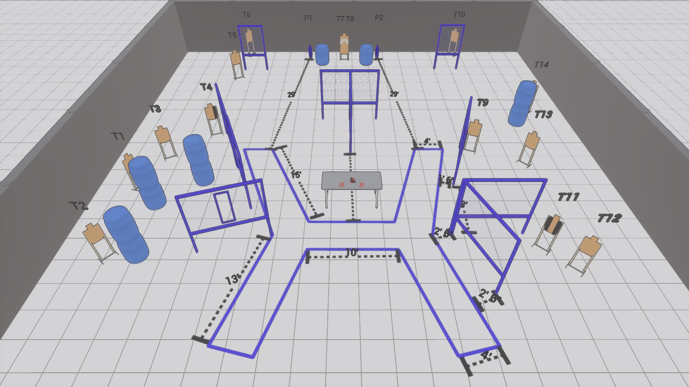

Written Stage Briefing:

Stage 3 – Mr. Poopy Says Practice More - is a 30 round, 150 point, Comstock Course. There are 14 cardboard targets and 2 steel targets.

Starting with palms of both hands flat on the table.
Gun is unloaded and placed unpropped on the table.

On the audible start signal, engage targets from within the shooting area.

USPSA / NROI Range Commands:
- Make Ready
- Are you ready?
- Standby
- If finished, unload and show clear
- If clear, hammer down and holster (Handgun)
If clear, hammer down and flag (PCC)
If clear, cylinder closed and holster (Revolver)
- Range is clear

Setup Notes:
16 Single Wall Stands
2 Double Wall Stands
7 Full Walls
2 Half Walls
13 Target stands / 26 target sticks
2 Mini Poppers + bases
10+ Barrels
